An Evening to Benefit Are You Dense Inc: Preventing late-stage cancers in Dense Breasts
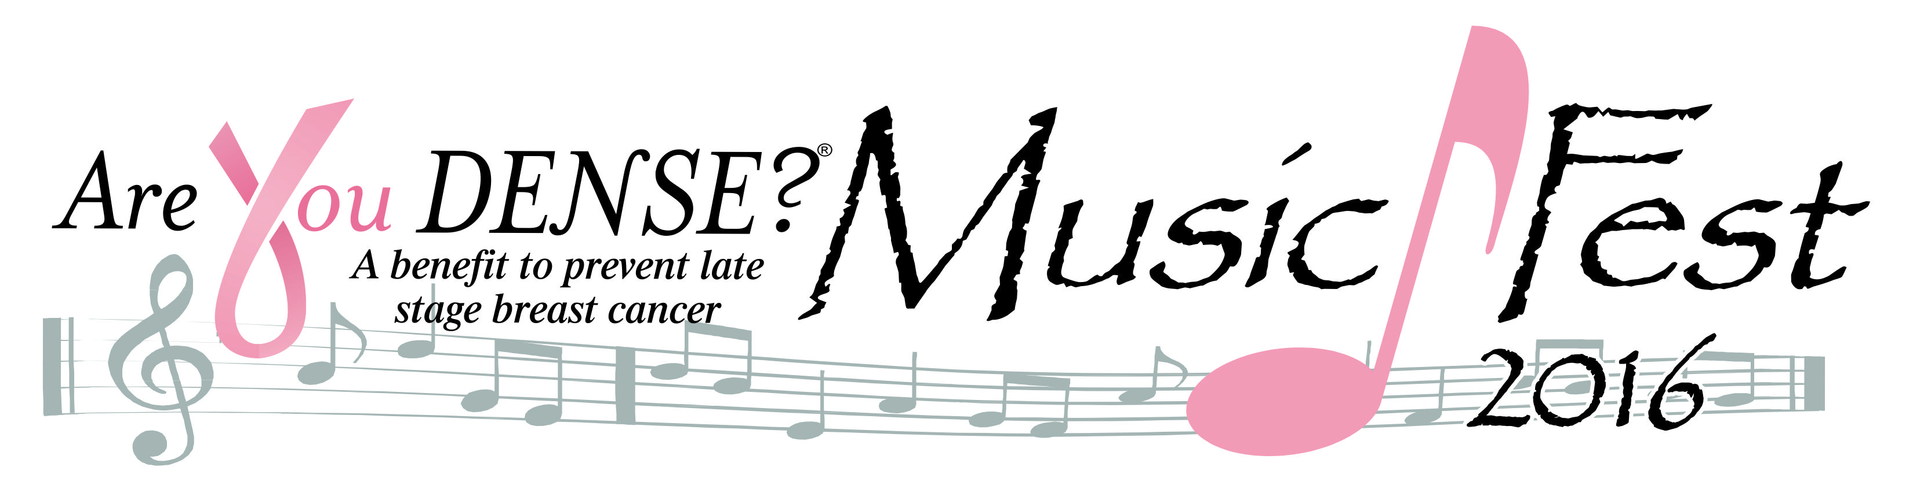
June 18, 2016 Historic Palace Theater Performing Arts Center Waterbury CT
Sponsorships*
PINK Presenting Sponsor $10,000
Name on Palace Theater Marquis at MusicFest event
Logo/name Linked to Are You Dense Website’s MusicFest promotions
Prominent Top Billing MusicFest media advertisements
Mention in all MusicFest promotions – TV/Radio including Social Media
Banner displayed @ Atrium Entrance to Theater
Featured in MusicFest article in AYDENSE Newsletter
Recipient of ‘AreYouDense Pink Presenting Sponsor’ on stage at MusicFest Event
Full Page Advertisement in Program Booklet
Exhibitor Table
8 VIP tickets – entrance to post event ‘meet & greet’ reception
PINK Ribbon Partner $5,000
Branding on MusicFest media advertisements
Logo/Business/Name linked to Are You Dense Website’s MusicFest promotions
Mention in MusicFest promotions - TV/Radio
Banner displayed @ event
Featured in MusicFest article in AYDense Newsletter
Full-Page Advertisement in Program booklet
Exhibitor Table
6 VIP tickets – entrance to post event ‘meet & greet’ reception
VIPink Reception $2,500
Featured in MusicFest article in AYDense Newsletter
Banner @ VIP reception
Half-page advertisement in Program Booklet
4 VIP tickets – entrance to post event ‘meet & greet’ reception
SOUL Survivor $1000
Featured in MusicFest article in AYDense Newsletter
Quarter-page advertisement in Program Booklet
4 reserve seating tickets
Band/Artist $500
Name announced on stage with artist introduction
Name listed on event timetable of the evening
2 reserve seating tickets

* Information on Sponsorships: Contact Donna Gentilozzi @ Donna@AreYouDense.org
or 203-232-0089



Are You Dense Inc. MusicFest Sponsorship Form
Palace Theater - June 18, 2016
Name:
Address:
Phone: | Email:
Contact:
SPONSORSHIP LEVEL
Pink Presenting Sponsor @ 10,000.00
Pink Ribbon Partner @5000.00
VIPink Reception @2500.00
Soul Survivor @1000.00
Band Sponsor@ 500.00
Total:

Credit Card #
Address:
City:
State: Zip:
CVV # Code
Expiration Date:
Depending on Sponsorship category, submit logo or banner, 5X8 Full Page Ad, 5X4 half-page Ad, business card/5X2 quarter-size AD to:
Donna M. Gentilozzi
96 Rowley Rd.
Woodbury CT 06798
Fax: 203-263-6329 Phone: 203-232-0089 Email to Donna@AreYouDense.org
Payment to: Are You Dense, Inc.
96 Rowley Rd. Woodbury, CT. 06798
AreYouDense.org

Are You Dense 501(c)(3) Public Charity
IRS ID# 26-3643216

THANK YOU!

