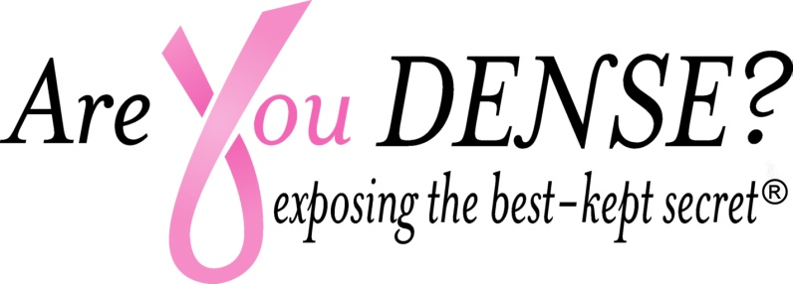
‘For the Girls’ 4th Annual Dinner and Auction Sponsorship Opportunities
Friday, October 27th Courtyard Marriot, Waterbury CT 6 to 10PM
Cheese /Fruit Display, Plated Dinner, Cash bar, Live ‘Secret’ Auction, Raffle, Dessert Auction, Vendors and Music by ‘Twist of Lime.’
Proceeds to support the Breast Health Nonprofit Are You Dense Inc.
Dr. Beth Sieling, Guest Auctioneer
For more information contact Donna Johnson
Djohnson@draxray or Info@areyoudense.org
Pink Presenting Event Sponsor $2500
Top Billing on flyer/website promotion
Top Billing on Program Agenda
Social Media Acknowledgement
Table to display resources, materials
Banner displayed at event
Featured in AYD newsletter promoting ‘For the Girls’
6 tickets to event
Pink Ribbon Sponsor $1500
Logo on flyer/website promotion
Logo on Program Agenda
Banner displayed at event
Featured in AYD Newsletter promoting For the Girls
4 tickets to event
Pink Centerpiece Sponsorship $500
Logo/name on Program Agenda
Name recognition on all Centerpieces
2 tickets to event
Friend of Exposing the Secret $100
Name on Program Agenda (in honor or recognition of someone)
1 Ticket to event
Checks payable to: Are You Dense Inc 96 Rowley Road Woodbury CT 06798
501(C)(3) Public Charity IRS#26-3643216

