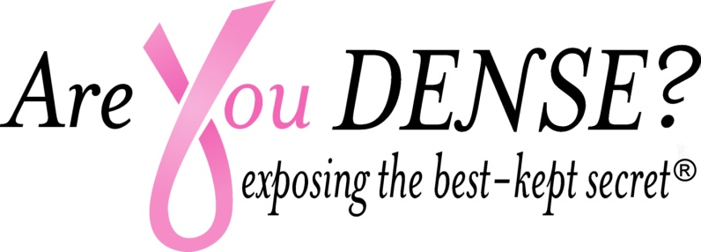
NEW Venue
VE
VENUE
V

‘For the Girls’ 5th Annual 
Brunch and Auction with Guest Auctioneer
Earlene Babcock
Sunday October 28, 2018 12-4 PM at Grand Oak Villa , Oakville CT
Executive Brunch w/Endless Bellinis & Mimosas
Live ‘Secret’ Auction, Raffle, Dessert Auction, Live Music by Twist of Lime – Tickets $45.00 online at AreYouDense.org
Sponsorship Opportunities
For more information contact Donna Johnson Djohnson@draxray.com or Info@areyoudense.org
Pink Presenting Event Sponsor $2500
Top Billing on flyer/website promotion
Top Billing on Program Agenda
Social Media Acknowledgement
Opportunity to Address Attendees
Table to display resources, materials
Featured in AYD newsletter promoting ‘For the Girls’
6 tickets to event
Pink Ribbon Sponsor $1500
Logo on flyer/website promotion
Logo on Program Agenda
Featured in AYD Newsletter promoting ‘For the Girls’
4 tickets to event
Pink Centerpiece Sponsorship $500
Logo/name on Program Agenda
Name recognition on all Centerpieces
2 tickets to event
Friend of Exposing the Secret $100
Name on Program Agenda (in honor or recognition of someone)
1 Ticket to event

Checks payable to: Are You Dense Inc 96 Rowley Road Woodbury CT 06798
501(C)(3) Public Charity IRS#26-3643216
For Credit Card payment Contact Info@AreYouDense.org

Are You Dense Inc. ‘For the Girls’ Sponsorship Form
Grand Oak Villa October 28th 2018
Name:
Address:
Phone: | Email:
Contact:
SPONSORSHIP LEVEL
Pink Presenting Event Sponsor @ 2500.00
Pink Ribbon Sponsor @1500.00
Pink Centerpiece @500.00
Friend of Are You Dense @100.00
Vendor Sponsor@ 100.00
Total:

Credit Card #
Address:
City:
State: Zip:
CVV # Code
Expiration Date:
Fax: 203-263-6329 Email to Info@areyoudense.org

Are You Dense, Inc.
96 Rowley Rd. Woodbury, CT. 06798
AreYouDense.org

Are You Dense 501(c)(3) Public Charity
IRS ID# 26-3643216

Thank you for supporting our Mission to prevent Missed, Delayed and advanced stage breast cancers in women with dense breasts.

